Mark Rieder
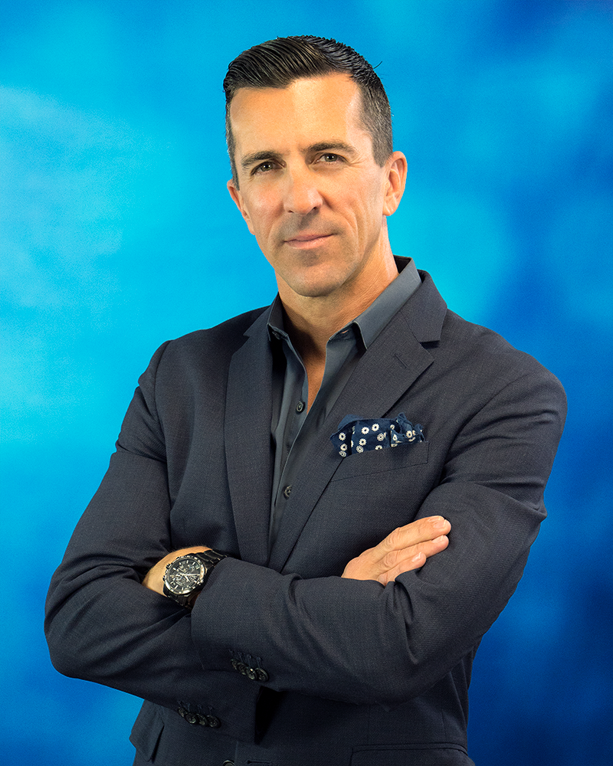
Mark Rieder
Head of Innovation
Head of Innovation

As Head of Innovation, Mark champions, develops and institutionalizes the innovation process for NFP both inside and outside our organization. Working in conjunction with our President/Chief Operating Officer and our Managing Director of Venture and Innovation, Mark serves as a leader in developing ideas for new technologies, products, services and practices. He works to drive adoption and manage high-quality execution across organizational lines while enhancing business outcomes by establishing processes that allow for cross-company collaboration, customer feedback and marketplace intelligence. Mark Rieder continuously identifies new market spaces, analyzes trends and market disruptions, and searches for emerging opportunities as he forges new relationships.
Having served in the employee benefits industry for over 20 years, including nine years as CEO of a leading employee benefits consulting firm based in the Philadelphia area, Mark joined NFP’s corporate team in January 2010 to launch the company’s national benefits administration practice. He has played an integral role in expanding the practice area to provide HRIS consulting services through its newly formed HR Services division, developing the NFP Marketplace – NFP’s exchange solution – and, most recently, launching the new NFP Innovation Group.

As a thought leader in the industry, Mark is the author of multiple white papers, speaks regularly at industry events and conference panels, is an instructor on NFP’s client-facing trainings and sits on a number of technological advisory boards. Mark has a bachelor’s in finance with an emphasis on economics from Pennsylvania State University.

