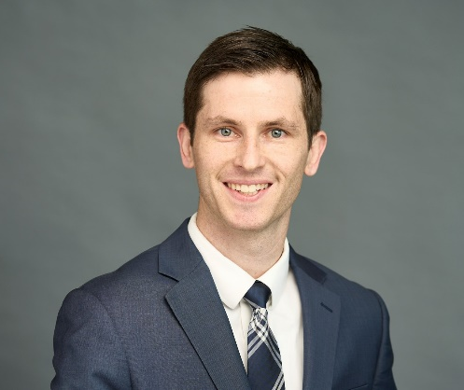

DAVID STODDARD
FSA, MAAA
Actuary

Director of Analytics and Actuarial Services

With more than 10 years of experience in the health care industry as a lead health benefits actuary, David has performed high impact actuarial consulting for large multi-state employers in a variety of industries. He has extensive expertise in creating data driven strategies and communicating complex health plan issues to a wide range of stakeholders.

David communicates his deep analytical skills and strategic understanding of employer total rewards strategies. He leverages these skills to evaluate programs and make recommendations that enhance plan value, mitigate risk, and bring cost-effective benefit plan solutions. He consults with clients on plan design modeling, pricing, claims trend analysis, budget projections, and IBNR reserve estimates, and utilizes detailed analytics to impact vendor renewal negotiations.

David relies on his strong technical expertise to design and build actuarial models and tools to advance service offerings within the Employee Benefits practice. He utilizes benchmarking and analytics to determine leading and lagging indicators, to develop and design valuable health and welfare programs.

Prior to joining World, David worked as a Consulting Actuary at Milliman, managing project teams, building models, and providing actuarial expertise to a broad range of clients.
As Director of Analytics and Actuarial Services, David leads national initiatives for World Insurance Associates, with a focus on creating new, scalable, and data driven solutions for clients.
David lives in Verona, NJ with his wife and two sons.

Education and Credentials
Bachelor of Arts, Mathematics with a Minor in Actuarial Studies from the College of New Jersey
Fellow of the Society of Actuaries
Member of the American Academy of Actuaries

